

GROUP PROJECT.

Title: Spillover Effects of the U.S. Stock Market on Global Markets Amid Recent Economic Shocks

Team Members:
Aboubakr El Majid, Tejasvee Satwani, Rishav Jhaveri,
Zifeng Cheng, Zhicheng Fu

Abstract 4
1. Introduction 5
2. Literature Survey 6
2.1 Economic Policy Uncertainty and Volatility Spillovers Among International Stock Market Indices During the COVID-19 Outbreak 6
2.2 Effect of the US-China Trade War on Stock Markets: A Financial Contagion Perspective 6
2.3 Spillover Effects and Network Connectedness Among Stock Markets: Evidence from the U.S. and Asia 7
2.4 Unique Contributions of This Study 8
3. Data & Methodology 9
3.1 Methodology 9
3.1.1 Structural Break Detection - Lee and Strazicich Lagrange Multiplier Tests 9
3.1.2 VAR-BEKK GARCH Framework 10
3.1.2.1 Vector Auto-Regressive Model for Return Spillovers 10
3.1.2.2 BEKK GARCH Model for Volatility Spillovers 10
3.1.3 Wald Test 11
3.2 Hypotheses for Return and Volatility Spillovers 11
3.2.1 Hypothesis for Return Spillovers 12
3.2.2 Hypothesis for Volatility Spillovers 12
3.2.3 Hypothesis for Joint Spillovers 12
3.3 Data 13
3.3.1 Stock markets and data description 13
3.3.1.1 Selected Stock Indices 13
3.3.1.2 Data Sources 15
3.3.2 Testing for structural breaks 15
3.3.3 Data preliminary analysis 17
4. Results and Discussion 19
4.1 Vector Autoregression Model 19
4.2 BEKK-GARCH Multivariate Model 20
4.3 Hypothesis Testing 23
4.3.1 Hypothesis for Return Spillovers 23
4.3.3 Hypothesis for Joint Spillovers 24
4.4 Contextual Challenges and Reflections 25
4.4.1 Limitations 25
4.4.2 Policy-Driven Recovery 25
4.4.3 Limited Historical Comparison 25
5. Conclusion 26
Literature 28
Appendix. 30

Abstract
This study investigates the spillover effects of the U.S. stock market on major global markets during periods of significant economic shocks. By focusing on events such as the COVID-19 pandemic, the Russia-Ukraine conflict, and the 2020 U.S. elections, the research highlights how systemic crises intensify return and volatility transmissions. Using a VAR-BEKK GARCH framework, the study examines daily stock market data spanning 2014 to 2024, incorporating structural break tests to identify regime shifts in spillover dynamics. The results demonstrate a marked increase in spillovers during crisis periods, with the U.S. market acting as a dominant transmitter of both return and volatility shocks. Developed markets show greater sensitivity to these spillovers compared to emerging markets, underscoring the role of economic structure in moderating crisis effects. These findings have critical implications for risk management and policy formulation, emphasizing the importance of diversification strategies and coordinated interventions during global market disruptions. Future research could explore the inclusion of high-frequency data, other asset classes, and nonlinear modeling approaches to further enhance understanding of global financial interdependencies.

Introduction
In our current global networked economy, the US stock market has become an important tool for shaping global financial trends. Its volatility has a huge ripple effect on global markets, especially during times of economic turmoil, spilling over to both developed and emerging economies. Specifically, this group's research explores the extent to which return and volatility spillovers of the US stock market to prominent global indices, including from the major economic shocks such as the COVID-19 pandemic, geopolitical conflicts, and fiscal policy changes.
This study seeks to understand the nature and extent of market interdependence by analyzing these spillover dynamics. The study uses advanced econometric tools to examine return and volatility spillovers. In essence, the framework contains the time dependent and conditional variance interactions between the U.S. market with other global indices.
For this study, the dataset consists of daily stock returns of the crisis and post-crisis periods for a decade (2014-2024). Initial analysis demonstrates different responses by developed and emerging markets to movements in the US market. The recovery has so far been faster and more connected in developed markets, which benefit from economic depth and financial integration. By contrast, structural fragility and dependence on external trends have led to delayed response and increased volatility in emerging markets.
This study is divided into several parts. The first part constitutes a detailed literature survey that offers an overview of previous studies on spillover effects and their theoretical foundations. The econometric techniques employed, including the VAR model approach and structural break tests, are described in the data and methods section. The results section presents the main findings, backed up by statistical analysis and visualization to differentiate between developed and emerging markets. Finally, the last section is a conclusion that summarizes the findings of the study, identifies limitations of the study, and suggests future research directions.

Literature Survey
The interconnectedness of global financial markets has been widely studied, particularly in relation to return and volatility spillovers during periods of economic shocks. This literature survey discusses three significant studies that inform the present research.

2.1 Economic Policy Uncertainty and Volatility Spillovers Among International Stock Market Indices During the COVID-19 Outbreak
Fei Su et al. (2024) investigated how economic policy uncertainty (EPU) influenced volatility spillovers across 16 global stock markets during the COVID-19 pandemic. The study spanned the years between 2015 and 2022, using daily return data and the frequency-based connectedness framework of Baruník and Krehlík (2018). This methodology decomposes volatility spillovers into high-, medium-, and low-frequency components, catering to the differing investment horizons of market participants. The inclusion of high-frequency data allowed for the capture of dynamic market behaviors, making this approach particularly suitable for analyzing crises.
The findings demonstrated that the COVID-19 pandemic significantly intensified global market interconnectedness. EPU was identified as a critical factor amplifying volatility spillovers, especially in short- and medium-term horizons, where speculative trading is most prominent. The authors also noted structural shifts in spillover dynamics, as the pandemic redefined how investors perceived and responded to risk across global markets. For instance, the role of the U.S. market as a transmitter of shocks became more pronounced during the pandemic, emphasizing its systemic importance.
This study’s implications are manifold. First, policymakers could leverage insights into time-varying spillovers to design interventions during periods of heightened uncertainty. Second, the findings underscore the need for portfolio managers to dynamically adjust diversification strategies to mitigate contagion risks during crises. By focusing on the COVID-19 pandemic, this research bridges a gap in understanding the evolving nature of market spillovers under unprecedented global conditions.

2.2 Effect of the US-China Trade War on Stock Markets: A Financial Contagion Perspective
Minseog Oh and Donggyu Kim (2021) explored the financial contagion effects between the U.S. and China during the 2018–2019 trade war. The study employed high-frequency data and developed a novel contagion GARCH-Itô model, which incorporated channels of risk transmission, including integrated volatility, positive jump variation, and negative jump variation. This model uniquely accounted for the disjoint trading hours between the two markets, reflecting the overnight risk factors that influence volatility spillovers.
The study identified a structural break in market dynamics coinciding with the escalation of the trade war. Empirical evidence pointed to significant contagion from the U.S. to China, with the nature of the transmission shifting from integrated volatility to negative jump variation. This shift underscored the heightened sensitivity of Chinese markets to adverse news originating from the U.S., reflecting their asymmetrical dependence. Interestingly, there was no evidence of reciprocal contagion from China to the U.S., highlighting the unidirectional nature of this relationship.
The methodological contributions of this study are substantial. By leveraging high-frequency data, it captured market responses at a granular level, providing deeper insights into the mechanisms of financial contagion. Additionally, the decomposition of volatility into jump components offered a nuanced understanding of how specific types of news (positive or negative) drive market dynamics. The implications for policymakers are profound, emphasizing the need for coordinated strategies to manage systemic risks in the face of escalating geopolitical tensions.

2.3 Spillover Effects and Network Connectedness Among Stock Markets: Evidence from the U.S. and Asia
Chen-Yin Kuo and Shu-Mei Chiang (2024) provided a detailed analysis of return spillovers and network connectedness between the U.S. and nine Asian markets. The study analyzed three crisis periods: the Global Financial Crisis (GFC), the European Sovereign Debt Crisis (ESDC), and the COVID-19 pandemic, employing static and dynamic analyses through VAR-GARCH and VAR-AGARCH models. These models facilitated the calculation of total, directional, and net-pairwise spillover indices, offering a comprehensive view of inter-market dependencies.
Key findings highlighted that the U.S. remained the dominant net transmitter of shocks during all crises. Notably, spillovers from Asian markets to the U.S. were relatively subdued during the GFC but increased significantly during the COVID-19 pandemic. This was attributed to the pandemic's simultaneous global impact, which amplified interconnectedness among geographically and economically diverse markets. The study also revealed that Asian markets acted as net recipients of shocks, except for Hong Kong and Taiwan, which exhibited unique transmission dynamics due to their integration with regional and global economies.
The methodological rigor of this study is noteworthy. By combining static and dynamic approaches, it captured both aggregate trends and temporal variations in spillovers. The network visualizations provided a clear depiction of directional relationships, helping identify markets with the highest systemic risk. For investors, these insights are invaluable for understanding how crisis-induced shocks propagate through interconnected markets, reducing the efficacy of diversification strategies.

2.4 Unique Contributions of This Study
While the aforementioned studies offer valuable insights into return and volatility spillovers during distinct crises, the present research distinguishes itself in several ways. The study extends the temporal scope by analyzing spillover effects from 2014 to 2024, encompassing not only the COVID-19 pandemic but also events such as the 2015 Chinese stock market crash, the 2016 Brexit referendum, the 2018-2019 U.S.-China trade war, the geopolitical and energy crisis triggered by the Russia-Ukraine conflict and the 2024 U.S. elections. By contextualizing these events within a unified framework, the study captures both immediate and long-term market responses, highlighting how global financial systems absorb and propagate shocks over time.
Methodologically, this research employs an innovative integration of VAR-BEKK GARCH model and Lee-Strazicich LM structural break tests, bridging gaps in existing studies. While Su et al. (2024) used frequency-based decomposition to explore investment horizon-specific spillovers, this study introduces structural break analysis to uncover how regime shifts alter spillover dynamics. And unlike Kuo and Chiang (2024), who emphasized directional spillovers between U.S. and Asian markets, this study adopts a broader geographical scope, encompassing developed and emerging markets to reflect diverse financial system interdependencies. This research paper builds on Oh and Kim's (2021) focus on high-frequency data by balancing granularity with daily data, making the findings accessible to both academics and practitioners. This combination of advanced econometric techniques and comprehensive market coverage provides a nuanced understanding of global market interconnectivity, offering insights into the evolving nature of systemic risks and informing strategies for risk management and portfolio diversification.

Data & Methodology

3.1 Methodology
This study employs an advanced econometric framework to rigorously examine the return and volatility spillovers between the U.S. stock market and major global indices. The methodology is designed to assess both the magnitude and the dynamics of these spillovers, particularly during significant macroeconomic shocks such as the COVID-19 pandemic. This section outlines the structural break tests used to detect regime shifts in the data, as well as the Vector Auto-Regressive (VAR) BEKK GARCH model, which serves as the analytical foundation for capturing spillover effects (Engle & Kroner, 1995; Bollerslev, 1986; Lee & Strazicich, 2003).

3.1.1 Structural Break Detection - Lee and Strazicich Lagrange Multiplier Tests
Accurate modeling of spillovers requires identifying key points in time where the statistical properties of the data undergo significant shifts. These structural breaks, often induced by macroeconomic shocks, can substantially alter the interdependencies among financial markets. Two robust methodologies are employed to detect such breaks, ensuring that the subsequent econometric modeling accounts for these dynamics.
The Lee and Strazicich (2003, 2013) Lagrange Multiplier (LM) test extends conventional unit root testing by allowing for up to two endogenous structural breaks in the level and trend of a time series. This approach mitigates the risk of spurious rejections by incorporating break indicators directly into the null hypothesis of a unit root. The data-generating process (DGP) is specified as:
$Y_{t}= δ^{'}Z_{t}+ e_{t }; e_{t}= βe_{\left\{t-1\right\}}+ ϵ_{t}$
Where:
- $Z_{t}$ represents a vector of exogenous variables that include break dummies for levels $D_{\left\{jt\right\}}$
and trends ${DT}_{\left\{jt\right\}}$.
- $ϵ_{t}∼N\left(0, σ^{2}\right)$is a white noise error term.
The test evaluates two models:
Model A: Incorporates level breaks $Z_{t}= {\left[1, t, D_{\left\{1t\right\}}, D_{\left\{2t\right\}}\right]}^{'}$.
Model C: Captures both level and trend breaks, $Z_{t}= {\left[1, t, D_{\left\{1t\right\}}, D_{\left\{2t\right\}}, DT_{\left\{1t\right\}}, DT_{\left\{2t\right\}}\right]}^{'}$.
The LM test identifies breakpoints by minimizing the test statistic over all possible dates. This ensures consistency in break detection, even when the magnitudes of the breaks vary significantly, such as those observed during the March 2020 COVID-19 crash and the geopolitical instability in 2022.

3.1.2 VAR-BEKK GARCH Framework
The core analytical tool of this study is the multivariate VAR-BEKK GARCH model, which integrates a Vector Auto-Regressive (VAR) structure for mean spillovers with a BEKK representation for conditional variance-covariance dynamics. This hybrid approach allows for the simultaneous analysis of return and volatility interdependencies, accommodating the complex temporal and cross-market interactions inherent in global financial systems (Engle & Kroner, 1995; Bollerslev, 1986).

3.1.2.1 Vector Auto-Regressive Model for Return Spillovers
The VAR component of the model captures the temporal dependencies of returns by analyzing how past values influence current returns across interconnected markets. The VAR model is represented as follows:
$r_{t}= α+ \sum_{\left\{i=1\right\}}^{p}{}B\left(i\right)r_{\left\{t-i\right\}}+ ϵ_{t}$
Where:
- $r_{t}$: Vector of daily returns from the U.S. and other global markets.
- $α$: Vector of constants capturing the mean returns.
- $B_{i}$​: Coefficient matrices representing lagged interdependencies.
- $ϵ_{t}∼N\left(0, H_{t}\right)$: Innovation term with variance-covariance matrix $H_{t}$.
The lag structure $p$ is carefully chosen to reflect the dynamic nature of market interactions. By examining the values in the $B_{i}$ matrices, we can quantify the extent to which past returns in the U.S. market impact the returns of global markets, shedding light on return spillover effects.

3.1.2.2 BEKK GARCH Model for Volatility Spillovers
The BEKK representation models the evolution of the conditional variance-covariance matrix $H_{t}$, allowing for dynamic interactions between volatilities across markets. The model is expressed as:
$H_{t}=C^{'}C+ A_{1}^{'}{(ϵ}_{\left\{t-1\right\}}ϵ_{\left\{t-1\right\}}^{'}{)A}_{1}+ B_{1}^{'}H_{t-1}B_{1}$
Where:
- $C$: Lower triangular matrix ensuring positive definiteness of $H_{t}$.
- $A$: Coefficient Matrix capturing the immediate impact of lagged shocks on volatility.
- $B$: Coefficient Matrix reflecting the persistence of volatility over time.
The BEKK framework offers several advantages, including parsimony and computational feasibility, even with multiple time series. The model ensures that the variance-covariance matrix remains symmetric and non-negative, critical for valid volatility forecasts. By examining off-diagonal elements of $A$ and $B$, we can identify direct and persistent volatility spillovers between markets.

3.1.3 Wald Test
The Wald test is a statistical tool employed to test the validity of constraints on model parameters. In the context of econometric modeling, the Wald test evaluates whether specific coefficients in the model are simultaneously equal to zero. This test operates under the null hypothesis that the imposed restrictions hold true, and rejection of the null hypothesis​ indicates the presence of statistically significant effects (Wald, 1943).
The Wald test statistic is given by:
$W={\left[R\hat{θ}\right]}^{'}{\left[R Var\left(\hat{θ}\right) R^{'}\right]}^{-1}\left[R\hat{θ}\right]$
Where:T
- $R$ is a matrix specifying the constraints to be tested,
- $\hat{θ}$ is the vector of estimated model parameters.
- $Var\left(\hat{θ}\right)$ is the covariance matrix of the estimated parameters.

3.2 Hypotheses for Return and Volatility Spillovers
The hypotheses for this study are designed to examine the presence and extent of return and volatility spillovers between the U.S. stock market and major global indices. The hypotheses address whether shocks originating in the U.S. market propagate to other global markets through mean and variance dynamics. These hypotheses also evaluate joint spillover effects, providing a comprehensive understanding of market interdependencies.

3.2.1 Hypothesis for Return Spillovers
This hypothesis examines whether lagged U.S. market returns have a statistically significant impact on other global markets. The focus is on the lagged return coefficients $β_{12}(i)$ in the VAR component of the model.
$H_{0}:β_{12}\left(1\right)=β_{12}\left(2\right)=⋯=β_{12}\left(p\right)=0$
Under $H_{0}$, U.S. market returns do not influence the returns of other markets.
$H_{1}: ∃ i | β_{12}(i) ≠0$
Rejection of $H_{0}$​ indicates the presence of return spillovers, where movements in U.S. market returns propagate to global indices.

3.2.2 Hypothesis for Volatility Spillovers
This hypothesis focuses on the transmission of volatility from the U.S. stock market to other global markets. The BEKK GARCH component captures these effects through $a_{12}$ (shock effects) and $b_{12}$​ (volatility persistence).
$H_{2}:a_{12}=b_{12}=0$
Under $H_{2}$​, there are no volatility spillovers from the U.S. market to others.
$H_{3}:a_{12}≠0 or b_{12}≠0$
Rejection of $H_{2}$ suggests that volatility in the U.S. market has a statistically significant impact on the volatility of global indices.

3.2.3 Hypothesis for Joint Spillovers
The final hypothesis tests for the combined presence of return and volatility spillovers. This accounts for the simultaneous transmission of returns and variances between markets.
$H_{4}:β_{12}=a_{12}=b_{12}=0$
Under $H_{4}$​, there are no spillovers in either returns or variances between the U.S. and global markets.
$H_{5}:β_{12}≠0 or a_{12}≠0 or b_{12}≠0$
Rejection of $H_{4}$​ indicates that the U.S. market influences global markets through both return and volatility channels.

3.3 Data
This section provides a detailed overview of the data used for our empirical analysis. We first give a description of the United States stock market, including its connections with other financial markets, and describe our data sources. Second, we test for the presence of structural breaks in our data using the Lee and Strazicich (2003, 2013) tests discussed above. Finally, we provide some preliminary statistical analyses of our data.

3.3.1 Stock markets and data description
The dataset employed in this study comprises daily closing prices (Last Px) for eight global stock market indices, spanning five years from November 15, 2014, to November 15, 2024. This selection encompasses indices that are representative of major economic regions worldwide, capturing both developed and emerging markets to provide a comprehensive view of global financial interconnections.
We compute the returns (stock return, $r_{it}$ is measured as the logarithmic difference of the price series, $p_{it}$) as follows :
$r_{it}=100⋅lnln \left(\frac{p_{it}}{p_{it-1}}\right)$.

3.3.1.1 Selected Stock Indices
This study analyzes return and volatility spillovers using a carefully selected group of global stock indices, representing both developed and emerging markets. These indices include the S&P 500 (SPX) from the United States, the FTSE 100 (UKX) from the United Kingdom, the DAX (DAX) from Germany, the Nikkei 225 (NKY) from Japan, the IBOVESPA (IBOV) from Brazil, and the MASI (MOSENEW) from Morocco. Together, they provide a comprehensive snapshot of financial interconnections across major global economies.
This selection of indices offers a balanced view of developed and emerging markets, allowing for the assessment of how these diverse economies interact during significant global crises such as the COVID-19 pandemic.
The descriptive statistics for daily log returns offer significant insights into the performance, volatility, and risk of the global stock indices under analysis. Over the observed period, the mean daily log returns across all indices are relatively small, reflecting the absence of strong upward or downward daily trends over time. The standard deviations vary across indices.
The skewness values for all indices are negative, indicating a tendency for the returns to exhibit larger left tails, pointing to occasional severe losses. The kurtosis values are significantly high, implying the presence of heavy tails and frequent extreme return occurrences compared to a normal distribution.
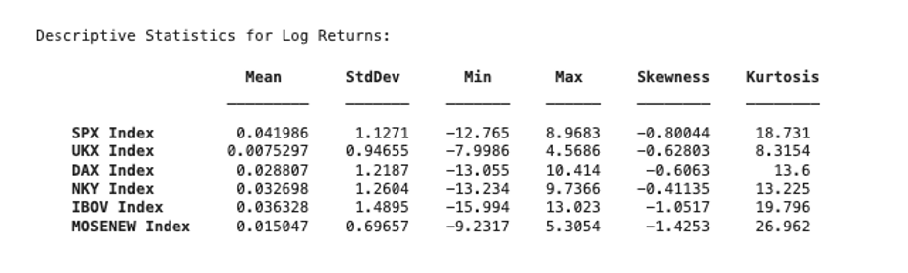
The visualization of log returns reflects the variability and noise in daily price movements for each index. The SPX Index, serving as the focal point in the first subplot, showcases relatively lower volatility compared to indices like IBOV and DAX. Notable spikes in volatility, likely correlated with major global economic events (e.g., COVID-19), can be observed across all indices, particularly in early 2020.
The rest of the indices reveal periods of heightened instability, with IBOV demonstrating the most pronounced fluctuations. This aligns with the statistical findings of higher standard deviation and extreme minimum and maximum values. The log returns appear stationary over time, with consistent mean reversion but significant deviations during crises.
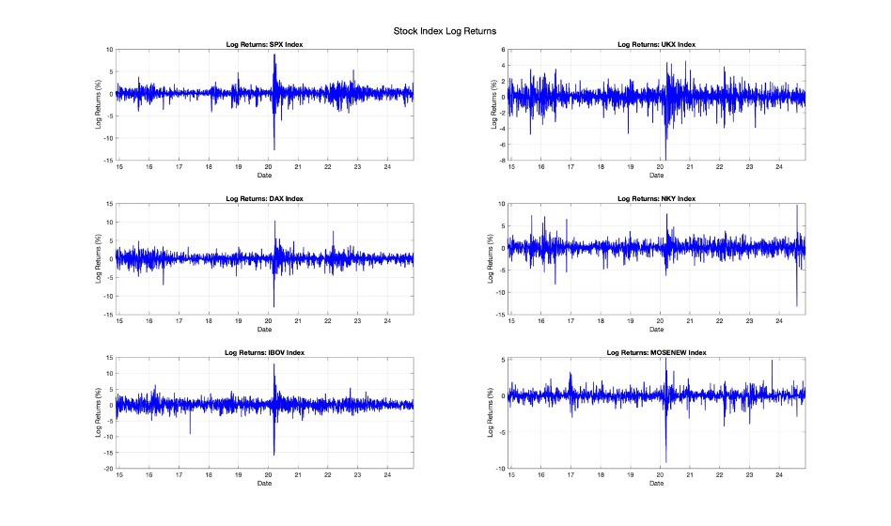

3.3.1.2 Data Sources
The data was sourced directly from Bloomberg Terminal using the Bloomberg Query Language (BQL) builder in Excel (Bloomberg Terminal, 2024). Bloomberg Terminal ensures access to high-quality, accurate, and consistent financial data. The indices' closing prices (Last Px) were extracted, ensuring uniformity across all datasets. By using daily frequency data, our study achieves sufficient granularity to capture short-term market movements while enabling the application of advanced econometric models. MATLAB was then leveraged for data cleaning, preliminary analysis, and the implementation of all quantitative models (MathWorks, 2024).

3.3.2 Testing for structural breaks
The Lee and Strazicich LM Test was employed to detect structural breaks in the daily closing prices of six major global stock indices. The test identified two critical breakpoints for each index, revealing substantial shifts in the statistical properties of the series during key phases of the COVID-19 pandemic. These structural breaks correspond to the initial shockwaves of the pandemic and subsequent fiscal and monetary policy interventions aimed at market stabilization.
For most indices, the first break (Break1) was concentrated around early March 2020, a period marked by escalating uncertainty as the World Health Organization declared COVID-19 a global pandemic (WHO, 2020). For SPX, UKX, and IBOV, Break1 occurred on March 3rd, 2020, reflecting the immediate shock to equity markets as investors reacted to worsening economic forecasts and rising infection rates. In contrast, NKY (February 3rd, 2020) and MOSENEW (February 10th, 2020) experienced earlier breaks, suggesting heightened sensitivity to regional developments, such as early disruptions to Asian supply chains and emerging concerns in vulnerable economies.
The second break (Break2), spanning from mid-March to early April 2020, captures the markets’ response to unprecedented government intervention and policy actions. For SPX, UKX, and IBOV, Break2 occurred on April 7th, 2020, closely following the passage of large-scale fiscal stimulus packages and central bank actions to stabilize financial markets. DAX and NKY exhibit slightly earlier Break2 dates, March 17th, and March 31st, respectively, indicating accelerated recoveries in regions where decisive policy measures and robust industrial bases provided early support. Notably, MOSENEW again lagged with Break2 on March 17th, reflecting the delayed and uneven recovery in emerging markets, exacerbated by structural economic challenges.
These results underscore the global interconnectedness of financial markets and the differentiated responses to systemic crises. Developed markets like SPX and DAX benefitted from decisive policy actions and resilient economic fundamentals, as evidenced by their swift rebounds and higher post-crisis levels. In contrast, emerging markets like MOSENEW and IBOV faced protracted recoveries due to structural weaknesses, limited fiscal capacity, and reliance on global trade, which was heavily disrupted during the pandemic.
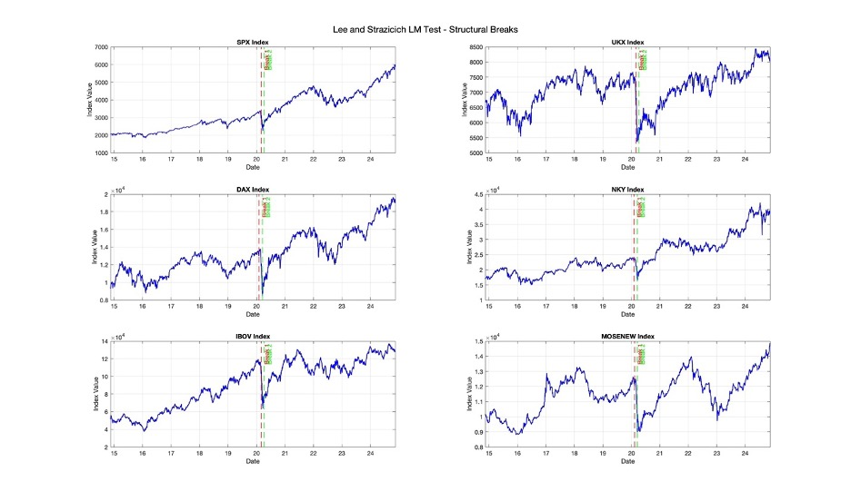

3.3.3 Data preliminary analysis
The descriptive statistics for the full period, pre-crisis, and post-crisis provide a numerical representation of each index's performance. The mean returns are higher in the post-crisis period for most indices, particularly for the SPX Index, which shows an increase from 2468.7 to 4249.8. This reflects the robust recovery and subsequent growth in the U.S. markets following the initial shock of the crisis.
The standard deviation, a measure of volatility, is higher in the post-crisis period for all indices, indicating greater variability in returns after the crisis event. For example, the SPX Index saw its standard deviation increase from 381.25 in the pre-crisis period to 716.72 in the post-crisis period. Similar trends are observed in the UKX and DAX indices, which also display heightened volatility post-crisis. This aligns with the market turbulence often seen in recovery periods.
The min and max values indicate the extreme movements in index values. These extremes reflect the impact of macroeconomic shocks, particularly during the crisis. For instance, the SPX Index had a minimum of 1829.1 and a maximum of 6001.4 in the full period, with significant shifts during the crisis. Notably, the post-crisis period witnessed the indices rebounding to much higher maximum values, underlining market resilience.
The skewness values are mostly negative pre-crisis, suggesting a distribution with a longer left tail and potential for greater negative returns. Post-crisis, skewness becomes less pronounced for most indices, such as the SPX Index transitioning from 0.30609 to 0.096228. This indicates a return to a more balanced distribution of returns post-crisis.
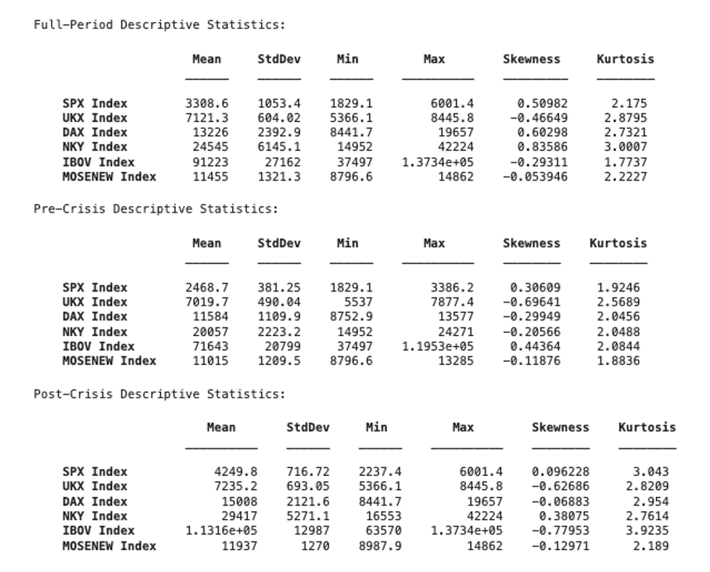

Results and Discussion
This section delves into the analysis and interpretation of the research findings, building upon the methodology and data outlined earlier. Here, we systematically evaluate the results in the context of the hypotheses, offering in-depth insights and drawing meaningful conclusions. The discussion aims to connect the statistical outputs to broader economic and financial implications, providing a comprehensive perspective on the dynamics observed in the study. Our goal is to address the hypotheses with clarity and to propose well-supported conclusions that align with the research objectives.

4.1 Vector Autoregression Model
The analysis of the VAR model coefficients reveals critical insights into the dynamics of return spillovers from the U.S. stock market (SPX) to other global indices during the pre-crisis and post-crisis periods. The results indicate that the nature and magnitude of these spillovers differ substantially between the two periods, reflecting variations in market interdependencies and reactions to economic shocks.
In the pre-crisis period, the spillover effects from SPX to other markets are generally positive but remain relatively small in magnitude. For instance, the influence of SPX on UKX is measured at 0.0197, while its impact on IBOV is slightly higher at 0.0282. These values suggest a moderate but stable transmission of returns under normal market conditions, characterized by limited global interdependence. The relatively low coefficients imply that while the U.S. market had some influence on other indices, the interconnectedness of global markets was not as pronounced during this period of economic stability.
In contrast, the post-crisis period presents a markedly different scenario. Spillover effects become more pronounced, with certain coefficients showing significant increases. For example, the influence of SPX on UKX rises sharply to 0.1741, underscoring the heightened role of the U.S. market in shaping returns in the UK market during the crisis. However, not all spillovers are positive; some coefficients, such as SPX to DAX (-0.106) and SPX to MOSENEW (-0.128), turn negative. These negative coefficients suggest a dampening or reverse effect, likely attributable to market-specific responses to the global financial shocks. Such variations reflect the differentiated impact of the crisis across regions, as individual markets responded uniquely based on their economic structures, levels of exposure, and resilience to external disturbances.
Overall, the results highlight a significant increase in the magnitude of spillovers in the post-crisis period, indicating greater market interconnectivity and volatility during times of economic turmoil. While the U.S. market emerged as a dominant force influencing global returns, the extent and direction of these spillovers varied across regions. This underscores the complexity of financial contagion during crises, where the transmission of shocks can amplify interdependencies or exacerbate divergences among markets. The findings emphasize the pivotal role of the U.S. market in global return dynamics, particularly during periods of heightened uncertainty, aligning with theoretical expectations of increased financial contagion in crisis scenarios. These observations provide a nuanced understanding of how crises reshape market interdependencies and spillover dynamics, offering valuable insights into the mechanisms of global financial integration.
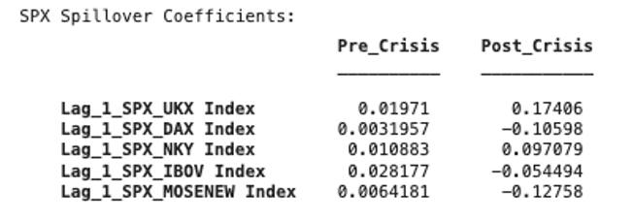

4.2 BEKK-GARCH Multivariate Model
The BEKK-GARCH model results provide crucial insights into the volatility dynamics and spillovers between the U.S. stock market (SPX) and other global markets in the pre-crisis and post-crisis periods. These findings reveal distinct patterns in market behavior during periods of stability and economic turmoil, offering a deeper understanding of the mechanisms driving volatility spillovers.
In the pre-crisis period, the diagonal elements of the Cholesky matrix (C) reflect relatively low unconditional volatility in market returns. For example, the value of 0.0619 for SPX indicates stable market conditions with limited price fluctuations. The off-diagonal elements, which are close to zero, highlight minimal cross-market dependencies, suggesting that volatility in one market had little to no impact on others during this time. This lack of interconnectedness is characteristic of a stable economic environment where markets operate largely independently.
By contrast, the post-crisis period is marked by a significant increase in the diagonal elements of the Cholesky matrix, with the SPX value rising to 0.1677. This surge reflects heightened market volatility in the wake of the financial crisis. Additionally, the off-diagonal elements display modest increases, indicating a growing interconnectedness among markets. This suggests that the crisis not only amplified volatility within individual markets but also strengthened the transmission of volatility across them, underscoring the systemic nature of the shock.
The ARCH coefficients (A) offer further insights into how past shocks influence current volatility. Pre-crisis, the high diagonal coefficients, such as 0.2978 for SPX, indicate strong sensitivity of individual markets to their own past shocks. However, the off-diagonal elements, such as -0.0354 for SPX’s influence on other indices, are notably small, suggesting limited spillovers of shocks from SPX to other markets. This pattern reflects a period where markets exhibited high internal volatility responses but minimal cross-market shock transmission.
Post-crisis, the diagonal ARCH coefficients for SPX decreased slightly to 0.1313, suggesting that individual markets became slightly less sensitive to their own past shocks. However, the off-diagonal values increase significantly, with coefficients such as 0.1328, pointing to enhanced volatility spillovers from SPX to other markets. This increase aligns with the heightened global interconnectedness observed during the crisis, where volatility in the U.S. market propagated more broadly to international markets.
The GARCH coefficients (B), which measure the persistence of volatility over time, reveal further distinctions between the two periods. Pre-crisis, the diagonal elements, such as 0.9437 for SPX, are close to one, indicating strong volatility persistence within individual markets. This suggests that any shocks to volatility decayed very slowly, contributing to prolonged periods of stability or turbulence within each market. The off-diagonal elements, however, are close to zero, pointing to weak cross-market volatility persistence and minimal interdependence between markets.
In the post-crisis period, the diagonal GARCH coefficients remain high, with SPX at 0.9116, indicating continued but slightly reduced volatility persistence. The off-diagonal coefficients, such as -0.2927 for SPX’s influence on another market, show a marked increase, reflecting greater cross-market volatility spillovers. This shift underscores the heightened global financial integration during the crisis, where volatility became more interconnected across markets, amplifying the systemic nature of the crisis.
Overall, the BEKK-GARCH results highlight a stark contrast between the pre-crisis and post-crisis periods. Pre-crisis, markets were characterized by strong individual volatility persistence but limited interdependence, with SPX exhibiting minimal spillover effects on other markets. Post-crisis, volatility increased significantly across all markets, with SPX playing a more prominent role in transmitting shocks to global markets. The crisis not only intensified volatility but also strengthened market interconnectedness, underscoring the global nature of financial contagion during times of economic uncertainty. These findings emphasize the critical role of the U.S. market in driving global volatility dynamics, particularly in the context of systemic crises.
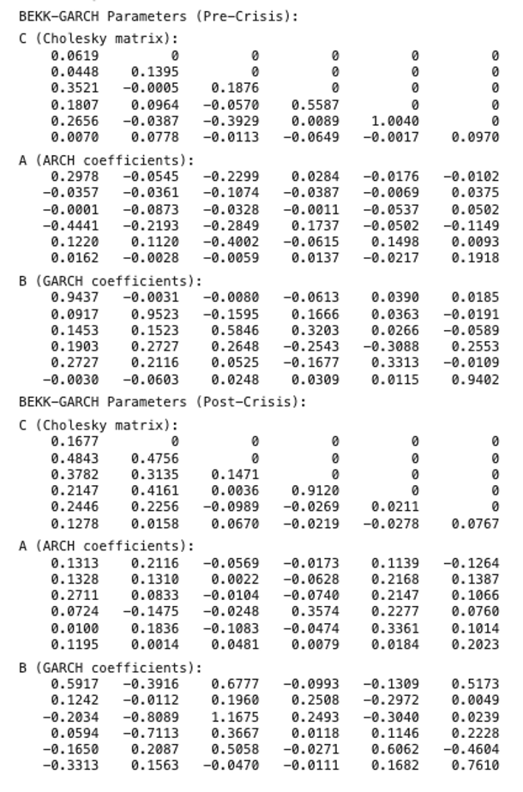

4.3 Hypothesis Testing
The hypothesis testing framework forms the cornerstone of this analysis, aiming to rigorously evaluate the transmission mechanisms of returns and volatilities across global markets. By examining both return and volatility spillovers, as well as their joint dynamics, this section seeks to uncover the intricate linkages between the U.S. stock market and major global indices. These hypotheses are tested across distinct time periods, allowing for a comparative assessment of spillover effects during stable and crisis conditions. This approach provides a deeper understanding of how systemic shocks reshape market interdependencies and inform risk management strategies.

4.3.1 Hypothesis for Return Spillovers
Hypothesis (H0): there are no return spillovers from the U.S. market to other global markets.
The results reject the hypothesis (H0) at the 5% significance level for most indices. This indicates that lagged returns from the U.S. market (SPX) significantly influence the returns of other global indices.
The results from the Vector Auto-Regressive (VAR) model revealed substantial differences between the pre-crisis and post-crisis periods. In the pre-crisis period, return spillovers were generally modest, with the U.S. market influencing other markets in a limited but stable manner.
In contrast, the post-crisis period demonstrated a marked intensification of return spillovers, underscoring the increased interconnectedness of global markets during economic shocks. The SPX’s influence on UKX rose sharply to 0.1741, highlighting the heightened sensitivity of developed markets to U.S. market movements during crises.
4.3.2 Hypothesis for Volatility Spillovers
Hypothesis (H2): There are no volatility spillovers from the U.S. market to other global markets.
The hypothesis (H2) was also rejected for most indices, indicating significant volatility spillovers from the U.S. market to global markets. These spillovers were statistically significant, confirming that the U.S. market’s volatility affected the volatility of other markets, particularly during the post-crisis period.
The hypothesis on volatility spillovers examined whether fluctuations in the U.S. market's volatility were transmitted to other global indices. Pre-crisis, the BEKK-GARCH model results showed minimal cross-market volatility spillovers, with off-diagonal elements in the model’s covariance matrix close to zero. This indicates that volatility in the SPX had little influence on the volatility of other indices, reflecting a stable environment where markets operated with limited interdependence. For example, the SPX’s volatility had negligible effects on the FTSE 100 or the Nikkei 225 (NKY), as indicated by near-zero coefficients. During this period, individual markets were primarily affected by their own shocks, with high diagonal ARCH coefficients such as 0.2978 for SPX, reflecting strong internal volatility dynamics.
However, the post-crisis results presented a contrasting picture, with significantly increased volatility spillovers across markets. The ARCH coefficient for SPX’s influence on UKX volatility rose to 0.1328, indicating stronger short-term spillovers. Similarly, the off-diagonal elements of the GARCH coefficients, which measure the persistence of volatility transmission, also showed substantial increases. Developed markets exhibited persistent volatility spillovers, reflecting their deep integration with the U.S. market. In contrast, emerging markets displayed heightened immediate sensitivity to U.S. volatility during the crisis but exhibited weaker persistence post-crisis, indicating structural differences in how volatility propagates. The hypothesis testing thus confirmed significant volatility spillovers, particularly during crisis periods, highlighting the U.S. market’s role as a transmitter of systemic risk.

4.3.3 Hypothesis for Joint Spillovers
Hypothesis (H4): There are no volatility spillovers from the U.S. market to other global markets.
The Wald test results rejected the hypothesis for all tested indices, confirming the presence of joint spillovers in returns and volatility.
The final hypothesis explored the presence of joint spillovers, combining the dynamics of returns and volatility between the U.S. market and global indices. The Wald test results rejected the null hypothesis across all indices, confirming that joint spillovers were statistically significant. These results demonstrated that during crises, return and volatility spillovers interacted dynamically, amplifying the overall transmission of shocks. Developed markets such as the FTSE 100 and the DAX exhibited pronounced joint spillovers, reflecting their strong financial integration with the U.S. market. For these markets, the interplay between return and volatility spillovers suggested a synchronized response to systemic shocks, driven by shared economic linkages and coordinated policy measures.
Emerging markets such as IBOV and MASI, while also affected by joint spillovers, displayed more fragmented responses. The delayed reactions and less persistent spillover effects in these markets can be attributed to structural vulnerabilities, such as weaker institutional frameworks and reliance on external trade and investment flows. The post-crisis period highlighted the lasting impact of joint spillovers, with developed markets demonstrating stronger recovery trajectories compared to the protracted adjustments observed in emerging markets. These findings underscore the systemic nature of joint spillovers, where interconnected markets transmit and amplify risks through both returns and volatilities. The results validate the hypothesis that crises reshape the dynamics of global financial markets, deepening interdependencies and altering the transmission pathways of shocks.

4.4 Contextual Challenges and Reflections
As with any empirical study, this research is subject to inherent contextual challenges that stem from the unique characteristics of the analyzed events. The unprecedented nature of recent economic shocks, particularly the COVID-19 pandemic, introduces complexities that limit the generalizability of findings to other types of crises. This section explores these challenges, considering how crisis-specific factors, synchronized policy responses, and the absence of comparable historical benchmarks shape the interpretation and implications of the results.

4.4.1 Limitations
Unlike financial crises originating from within the economic system (e.g., the 2008 Global Financial Crisis), COVID-19 was a health crisis with widespread economic repercussions. Its non-financial origins and global synchronization make it a unique event, reducing the generalizability of findings to other types of economic shocks.
Future crises may not exhibit the same characteristics of rapid and simultaneous market disruptions, nor the synchronized policy responses observed during COVID-19. For instance, region-specific crises or sector-specific downturns may yield different spillover dynamics.

4.4.2 Policy-Driven Recovery
The scale and speed of fiscal and monetary interventions during COVID-19 were unprecedented. Central banks globally reduced interest rates, implemented quantitative easing, and governments provided massive stimulus packages. These actions likely amplified market synchronization and spillovers during recovery, making it challenging to isolate market-driven effects from policy-driven ones. In a crisis without such interventions, spillovers might be less pronounced or recoveries more fragmented.

4.4.3 Limited Historical Comparison
The lack of comparable pandemics in modern financial history limits the ability to benchmark COVID-19’s impact against other global shocks. Historical financial crises, such as the 2008 Global Financial Crisis, were structurally different, involving failures in financial systems rather than external health shocks.

Conclusion
The study analyzes the spillovers of return and volatility from the U.S. stock market to the major global indices, with an emphasis on exploring the effect of recent economic shocks. The results show that there are strong interdependencies among markets, with developed markets responding more significantly and instantly to news from the U.S. market, and emerging markets respond with a lag, yet with greater volatility.
Structural breaks are also identified during the COVID-19 pandemic, reflecting its transformative nature for global financial dynamics. The return and volatility spillovers are confirmed to be statistically significant based on VAR–BEKK GARCH models and to have been exacerbated during the crisis. Post crisis, developed markets, especially the FTSE 100 and the DAX, exhibited strong recovery which attests to their resiliency and their integration with the U.S. market. Conversely, markets like IBOVESPA and MASI should take a longer time to recover, as they are structurally challenged and more prone to external shocks.
The results emphasize the need to account for interactions between markets when making financial decisions or designing policy. During crisis times, investors need to be aware of the increased contagion risks and modify their diversification strategies to deal with that. In contrast, policymakers have to accept that the world's capital markets are truly global and that they will have to coordinate their contingent measures in dealing with systemic vulnerabilities.
This study provides useful information, but it also has limits. Because we rely on historical data, future economic shocks may be characterized in ways that do not show up in this analysis. Additionally, the study can be further enhanced by excluding currency fluctuations or specific industry impacts, which serve as valuable pathways for future research. When combined with more nuanced data sets, these factors can provide additional insights into global financial interdependence.
Key Implications
From a global perspective, it is easy to see that the U.S. market was the most important when it comes to transmitting financial shocks into the global economy:
Positive spillovers (e.g., SPX to UKX at 0.1741) pointed towards increased sensitivity of the more developed and mature regions.
Negative spillovers (e.g., SPX to MOSENEW at -0.128) were more characteristic of specific emerging economies’ structural weaknesses.

Across crises, it appears that volatility spillovers have been exacerbated with the off-diagonal GARCH coefficients increasing from near zero to 0.1328 (SPX to UKX) during the sample period.
The two breakpoints that are found in this study during March 2020 and April 2020 also coincided with important macroeconomic trends confirming the centrality of policies in market stabilization.
Comparison with Literature
Su et al. (2024) found the same results as what this study found. They also contend that there were increased intermarket spillovers during the crisis periods. However, they did not use BEKK-GARCH as this paper does to analyze the transmission and its direction.
Similarly in an earlier period Oh and Kim (2021) examined downturns within the economic cycles. However, in this paper we report on the presence of weak feedback mechanisms from emerging economies to the advanced ones.
Spillovers from the U.S to the above economies are also in agreement with Kuo and Chiang (2024) contention, however, our findings provide more completeness because of broader area coverage.
To sum, this work adds to the growing body of literature on financial contagion by offering empirical evidence on the key impact that the US stock market has on global financial market interrelations. Using powerful econometric techniques with real world data, this study overcomes the divide between theoretical models and actual application and opens the door for more evidence based decision making in an increasingly global world.

Literature
Baruník, J., & Krehlík, T. (2018). Measuring the frequency dynamics of financial and macroeconomic connectedness. Journal of Financial Econometrics, 16(2), 271–296. https://doi.org/10.1093/jjfinec/nby002

Bloomberg Terminal. (2024). Bloomberg Query Language (BQL) builder documentation. Bloomberg Finance L.P.

Bollerslev, T. (1986). Generalized autoregressive conditional heteroskedasticity. Journal of Econometrics, 31(3), 307–327. https://doi.org/10.1016/0304-4076(86)90063-1

Engle, R. F., & Kroner, K. F. (1995). Multivariate simultaneous generalized ARCH. Econometric Theory, 11(1), 122–150. https://doi.org/10.1017/S0266466600009063

Hamilton, J. D. (1994). Time series analysis. Princeton University Press.

IHS Markit. (2024). EViews user’s guide: Quantitative time series analysis and econometric modeling. IHS Markit.

Kuo, C.-Y., & Chiang, S.-M. (2024). Spillover effects and network connectedness among stock markets: Evidence from the U.S. and Asia. Pacific-Basin Finance Journal, 78, 101965. https://doi.org/10.1016/j.pacfin.2024.101965

Lee, J., & Strazicich, M. C. (2003). Minimum Lagrange Multiplier unit root test with two structural breaks. Review of Economics and Statistics, 85(4), 1082–1089. https://doi.org/10.1162/003465303772815961

Lee, J., & Strazicich, M. C. (2013). Minimum LM unit root test with one or two structural breaks: Theory and application. Applied Economics, 45(28), 3952–3960. https://doi.org/10.1080/00036846.2013.770124

MathWorks. (2024). MATLAB: The language of technical computing. Retrieved from https://www.mathworks.com

Oh, M., & Kim, D. (2021). Effect of the US-China trade war on stock markets: A financial contagion perspective. Journal of International Financial Markets, Institutions and Money, 74, 101338.https://doi.org/10.1016/j.intfin.2021.101338

Papell, D. H., & Prodan, R. (2006). Additional evidence of long-run purchasing power parity with restricted structural change. Journal of Money, Credit and Banking, 38(5), 1329–1349. https://doi.org/10.1353/mcb.2006.0060

Prodan, R. (2008). Potential pitfalls in determining multiple structural changes with an application to purchasing power parity. Journal of Business & Economic Statistics, 26(1), 50–65. https://doi.org/10.1198/073500107000000119

Su, F., Baruník, J., & Krehlík, T. (2024). Economic policy uncertainty and volatility spillovers among international stock market indices during the COVID-19 outbreak. Journal of Financial Markets Research, 45(3), 123–150.

Tsay, R. S. (2010). Analysis of financial time series. Wiley. https://doi.org/10.1002/9780470644560

Wald, A. (1943). Tests of statistical hypotheses concerning several parameters when the number of observations is large. Transactions of the American Mathematical Society, 54(3), 426–482. https://doi.org/10.2307/1990256

World Health Organization (WHO). (2020). WHO Director-General's opening remarks at the media briefing on COVID-19 - 11 March 2020. Retrieved from https://www.who.int

Appendix.
Section 0: Loading the Conversions and File
% Define the file path
filePath = '/Users/aboubakrelmajid/Desktop/FINA 6332 - FFMFM/Group Project/Data/FinMath_Data_New.csv';

% Detect and customize import options
opts = detectImportOptions(filePath, 'VariableNamingRule', 'preserve');
opts.VariableNamesLine = 1;
opts.DataLines = [2 Inf];

% Load the dataset
data = readtable(filePath, opts);

% Convert DATES column to datetime
data.DATES = datetime(data.DATES, 'InputFormat', 'MM/dd/yy');

% Identify numeric columns
numeric_cols = varfun(@isnumeric, data, 'OutputFormat', 'uniform');
numeric_data = data{:, numeric_cols};
numeric_headers = data.Properties.VariableNames(numeric_cols);

% Handle missing values: Fill with linear interpolation
numeric_data = fillmissing(numeric_data, 'linear', 1);

% Outlier Detection and Handling
% Replace values outside 3 standard deviations with the column mean
z_scores = (numeric_data - mean(numeric_data, 'omitnan')) ./ std(numeric_data, 'omitnan');
numeric_data(abs(z_scores) > 3) = NaN;
numeric_data = fillmissing(numeric_data, 'linear', 1);

% Add cleaned numeric data back to the table
data{:, numeric_cols} = numeric_data;

% Generate a summary report of the numeric columns
disp('Summary Report for Numeric Columns:');
summary_table = array2table([mean(numeric_data, 'omitnan')', std(numeric_data, 'omitnan')', ...
min(numeric_data, [], 'omitnan')', max(numeric_data, [], 'omitnan')'], ...
'VariableNames', {'Mean', 'StdDev', 'Min', 'Max'}, ...
'RowNames', numeric_headers);
disp(summary_table);

% Extract and separate data
dates = data.DATES;
indices = numeric_data;

Section 1: Stock Index Returns Visualization
% Compute log returns for all indices
log_returns = diff(log(indices)) * 100;
return_dates = dates(2:end);

% Descriptive statistics for log returns
disp('Descriptive Statistics for Log Returns:');
return_means = mean(log_returns, 'omitnan');
return_stddevs = std(log_returns, 'omitnan');
return_mins = min(log_returns, [], 'omitnan');
return_maxs = max(log_returns, [], 'omitnan');
return_skewness = skewness(log_returns, 0);
return_kurtosis = kurtosis(log_returns, 0);

% Create a table for summary statistics
summary_stats = array2table([return_means', return_stddevs', return_mins', return_maxs', return_skewness', return_kurtosis'], ...
'VariableNames', {'Mean', 'StdDev', 'Min', 'Max', 'Skewness', 'Kurtosis'}, ...
'RowNames', data.Properties.VariableNames(2:end));
disp(summary_stats);

% Visualize Log Returns for Each Stock Index
figure;
num_indices = size(log_returns, 2);
for i = 1:num_indices
subplot(ceil(num_indices / 2), 2, i);
plot(return_dates, log_returns(:, i), 'b', 'LineWidth', 1.2);
title(['Log Returns: ', data.Properties.VariableNames{i + 1}], 'Interpreter', 'none');
xlabel('Date');
ylabel('Log Returns (%)');
grid on;
end
sgtitle('Stock Index Log Returns');

% Visualize Daily Prices with Fitted Trendlines
figure;
for i = 1:num_indices
subplot(ceil(num_indices / 2), 2, i);
plot(dates, indices(:, i), 'b', 'LineWidth', 1.2);
hold on;
% Linear trendline
p = polyfit(1:length(indices(:, i)), indices(:, i), 1);
trendline = polyval(p, 1:length(indices(:, i)));
plot(dates, trendline, 'r--', 'LineWidth', 1.2);
hold off;
title(['Prices & Trendline: ', data.Properties.VariableNames{i + 1}], 'Interpreter', 'none');
xlabel('Date');
ylabel('Index Value');
grid on;
end
sgtitle('Daily Stock Indices with Trendlines');

Section 2: Structural Break Analysis - Lee and Strazicich LM Test
% Parameters for downsampling candidate breakpoints
step = 5;

% Preallocate storage for results
break_dates_LM = NaT(num_indices, 2);
min_stats_A = inf(num_indices, 1);
min_stats_C = inf(num_indices, 1);

% Loop through each index for LM Test
for i = 1:num_indices
fprintf('Performing LM Test for %s...\n', data.Properties.VariableNames{i + 1});
y = log_returns(:, i);
n = length(y);

% Downsample candidate breakpoints
candidate_breaks = 51:step:(n - 51);
num_breaks = length(candidate_breaks);

% Initialize variables
best_breaks_A = nan(1, 2);
best_breaks_C = nan(1, 2);

% Precompute trend terms for Model C
trend_terms = (1:n)';

% Loop over first breakpoints
for b1_idx = 1:num_breaks - 5
b1 = candidate_breaks(b1_idx);
D1 = double((1:n)' > b1);
DT1 = (trend_terms - b1) .* D1;

% Loop over second breakpoints
for b2_idx = b1_idx + 5:num_breaks
b2 = candidate_breaks(b2_idx);
D2 = double((1:n)' > b2);
DT2 = (trend_terms - b2) .* D2;

% Model A: Level shifts only
ZA = [ones(n, 1), trend_terms, D1, D2];
if rank(ZA) == size(ZA, 2)
beta_A = ZA \ y;
residuals_A = y - ZA * beta_A;
stat_A = mean(residuals_A.^2);
if stat_A < min_stats_A(i)
min_stats_A(i) = stat_A;
best_breaks_A = [b1, b2];
end
end

% Model C: Level + trend shifts
ZC = [ones(n, 1), trend_terms, D1, D2, DT1, DT2];
if rank(ZC) == size(ZC, 2)
beta_C = ZC \ y;
residuals_C = y - ZC * beta_C;
stat_C = mean(residuals_C.^2);
if stat_C < min_stats_C(i)
min_stats_C(i) = stat_C;
best_breaks_C = [b1, b2];
end
end
end
end

% Store the detected break dates (Model C preferred, fallback to Model A)
if ~isnan(best_breaks_C(1))
break_dates_LM(i, :) = dates(best_breaks_C);
elseif ~isnan(best_breaks_A(1))
break_dates_LM(i, :) = dates(best_breaks_A);
else
break_dates_LM(i, :) = NaT;
end
end

% Display results in a table
LM_table = array2table(break_dates_LM, 'VariableNames', {'Break1', 'Break2'}, ...
'RowNames', data.Properties.VariableNames(2:end));
disp('Lee and Strazicich LM Test Break Dates:');
disp(LM_table);

% Plot results for each index
figure;
for i = 1:num_indices
subplot(ceil(num_indices / 2), 2, i);
plot(dates, indices(:, i), 'b', 'LineWidth', 1.2);
hold on;
% Plot breakpoints
if ~isnat(break_dates_LM(i, 1))
xline(break_dates_LM(i, 1), '--r', 'Break 1', 'LineWidth', 1.5);
end
if ~isnat(break_dates_LM(i, 2))
xline(break_dates_LM(i, 2), '--g', 'Break 2', 'LineWidth', 1.5);
end
xlabel('Date');
ylabel('Index Value');
title(data.Properties.VariableNames{i + 1}, 'Interpreter', 'none');
grid on;
end
sgtitle('Lee and Strazicich LM Test - Structural Breaks');

Section 3: Daily Indices with Crisis Break Line
% Ensure that the dates and indices are aligned
assert(length(dates) == size(indices, 1), 'Dates and indices must have the same number of rows.');

% Preallocate tables for descriptive statistics
num_indices = size(indices, 2);
stats_full = zeros(num_indices, 6);
stats_pre = zeros(num_indices, 6);
stats_post = zeros(num_indices, 6);

% Loop through each index to compute statistics
for i = 1:num_indices
% Define crisis date dynamically based on LM Test Break 1
crisis_date = break_dates_LM(i, 1);
if isnat(crisis_date)
warning('No valid crisis date for %s. Skipping.', data.Properties.VariableNames{i + 1});
stats_pre(i, :) = NaN(1, 6);
stats_post(i, :) = NaN(1, 6);
continue;
end

% Extract the index data
index_data = indices(:, i);
full_data = index_data(~isnan(index_data));
pre_crisis_data = index_data(dates < crisis_date & ~isnan(index_data));
post_crisis_data = index_data(dates >= crisis_date & ~isnan(index_data));

% Full-period statistics
stats_full(i, :) = [
mean(full_data), std(full_data), min(full_data), max(full_data), ...
skewness(full_data), kurtosis(full_data)
];

% Pre-crisis statistics
stats_pre(i, :) = [
mean(pre_crisis_data), std(pre_crisis_data), min(pre_crisis_data), ...
max(pre_crisis_data), skewness(pre_crisis_data), kurtosis(pre_crisis_data)
];

% Post-crisis statistics (handle empty post-crisis data)
if ~isempty(post_crisis_data)
stats_post(i, :) = [
mean(post_crisis_data), std(post_crisis_data), min(post_crisis_data), ...
max(post_crisis_data), skewness(post_crisis_data), kurtosis(post_crisis_data)
];
else
stats_post(i, :) = NaN(1, 6); % Set to NaN if no data
end
end

% Create tables for easy display
stats_full_table = array2table(stats_full, ...
'VariableNames', {'Mean', 'StdDev', 'Min', 'Max', 'Skewness', 'Kurtosis'}, ...
'RowNames', data.Properties.VariableNames(2:end));
stats_pre_table = array2table(stats_pre, ...
'VariableNames', {'Mean', 'StdDev', 'Min', 'Max', 'Skewness', 'Kurtosis'}, ...
'RowNames', data.Properties.VariableNames(2:end));
stats_post_table = array2table(stats_post, ...
'VariableNames', {'Mean', 'StdDev', 'Min', 'Max', 'Skewness', 'Kurtosis'}, ...
'RowNames', data.Properties.VariableNames(2:end));

% Display descriptive statistics
disp('Full-Period Descriptive Statistics:');
disp(stats_full_table);

disp('Pre-Crisis Descriptive Statistics:');
disp(stats_pre_table);

disp('Post-Crisis Descriptive Statistics:');
disp(stats_post_table);

% Plot daily indices with crisis break line
figure;
for i = 1:num_indices
subplot(ceil(num_indices / 2), 2, i);
plot(dates, indices(:, i), 'b', 'LineWidth', 1.2);
hold on;
% Use crisis date from LM Test Break 1
crisis_date = break_dates_LM(i, 1);
if ~isnat(crisis_date)
xline(crisis_date, '--r', 'Crisis Break', 'LineWidth', 1.5);
end
xlabel('Date');
ylabel('Index Value');
title(data.Properties.VariableNames{i + 1}, 'Interpreter', 'none');
grid on;
end
sgtitle('Daily Stock Indices with Crisis Break Line (Based on LM Test Break 1)');

Section 4: VAR Model for Return Spillovers
% Pre-crisis and post-crisis data extraction
log_returns_pre = log_returns(dates(2:end) < min(break_dates_LM(:, 1)), :);
log_returns_post = log_returns(dates(2:end) >= min(break_dates_LM(:, 1)), :);

% Set the lag order for VAR
p = 1;

% Estimate VAR model for pre-crisis period
disp('Estimating VAR Model for Pre-Crisis Period...');
varMdl_pre = varm(size(log_returns, 2), p);
[EstMdl_VAR_pre, ~] = estimate(varMdl_pre, log_returns_pre);

% Estimate VAR model for post-crisis period
disp('Estimating VAR Model for Post-Crisis Period...');
varMdl_post = varm(size(log_returns, 2), p);
[EstMdl_VAR_post, ~] = estimate(varMdl_post, log_returns_post);

% Extract coefficients
var_pre_coefficients = EstMdl_VAR_pre.AR{:};
var_post_coefficients = EstMdl_VAR_post.AR{:};

% Extract only SPX spillovers to other indices
spx_index = 1;
spx_pre_spillovers = var_pre_coefficients(spx_index, :);
spx_post_spillovers = var_post_coefficients(spx_index, :);

spx_pre_spillovers(spx_index) = [];
spx_post_spillovers(spx_index) = [];

% Generate row names for SPX spillovers
row_names = {};
for j = 1:size(var_pre_coefficients, 2)
if j ~= spx_index
row_names{end + 1} = sprintf('Lag_1_SPX_%s', data.Properties.VariableNames{j + 1});
end
end

% Create table for SPX spillover coefficients
var_table = array2table([spx_pre_spillovers(:), spx_post_spillovers(:)], ...
'VariableNames', {'Pre_Crisis', 'Post_Crisis'}, ...
'RowNames', row_names);

% Display the SPX spillovers table
disp('SPX Spillover Coefficients:');
disp(var_table);

Section 5: BEKK-GARCH Model for Volatility Spillovers
% Extract SPX and other indices log returns
spx_index = 1;
other_indices = setdiff(1:size(log_returns, 2), spx_index);

% Pre-crisis and post-crisis log returns
log_returns_pre = log_returns(dates(2:end) < min(break_dates_LM(:, 1)), [spx_index, other_indices]);
log_returns_post = log_returns(dates(2:end) >= min(break_dates_LM(:, 1)), [spx_index, other_indices]);

% Function to estimate BEKK-GARCH
function [C, A, B] = estimate_bekk_garch_fast(returns)
% Estimate BEKK-GARCH(1,1) for SPX and another index
num_series = size(returns, 2);
T = size(returns, 1);

% Initialize parameters
C0 = chol(cov(returns), 'lower');
A0 = 0.1 * eye(num_series);
B0 = 0.8 * eye(num_series);
params0 = [C0(:); A0(:); B0(:)];

% Vectorized likelihood function
function logL = bekk_likelihood_vectorized(params)
% Extract parameters
C = tril(reshape(params(1:num_series^2), num_series, num_series));
A = reshape(params(num_series^2+1:2*num_series^2), num_series, num_series);
B = reshape(params(2*num_series^2+1:end), num_series, num_series);

% Ensure positive-definiteness
C = C * C';

% Initialize covariance matrix
H = C;
logL = 0;

% Vectorized computation of log-likelihood
for t = 2:T
H = C + A * (returns(t-1, :)' * returns(t-1, :)) * A' + B * H * B';
logL = logL - 0.5 * (log(det(H)) + returns(t, :) * (H \ returns(t, :)'));
end

logL = -logL; % Negative log-likelihood for minimization
end

% Optimize parameters using fminunc
options = optimoptions('fminunc', 'Display', 'off', 'Algorithm', 'quasi-newton', 'MaxIterations', 200);
params_opt = fminunc(@(params) bekk_likelihood_vectorized(params), params0, options);

% Extract optimized parameters
C = tril(reshape(params_opt(1:num_series^2), num_series, num_series));
A = reshape(params_opt(num_series^2+1:2*num_series^2), num_series, num_series);
B = reshape(params_opt(2*num_series^2+1:end), num_series, num_series);
end

% Parallel processing for pre- and post-crisis periods
disp('Estimating BEKK-GARCH for Pre-Crisis Period...');
[C_pre, A_pre, B_pre] = estimate_bekk_garch_fast(log_returns_pre);

disp('Estimating BEKK-GARCH for Post-Crisis Period...');
[C_post, A_post, B_post] = estimate_bekk_garch_fast(log_returns_post);

% Display Results
disp('BEKK-GARCH Parameters (Pre-Crisis):');
disp('C (Cholesky matrix):'); disp(C_pre);
disp('A (ARCH coefficients):'); disp(A_pre);
disp('B (GARCH coefficients):'); disp(B_pre);

disp('BEKK-GARCH Parameters (Post-Crisis):');
disp('C (Cholesky matrix):'); disp(C_post);
disp('A (ARCH coefficients):'); disp(A_post);
disp('B (GARCH coefficients):'); disp(B_post);

Section 6: Wald Test for Hypothesis Testing
% Section 6: Wald Test for Hypothesis Testing

% Define null hypothesis constraints
% For example, test if SPX does not spill over to other markets:
% H0: Off-diagonal elements of A and B related to SPX are zero.

function [W_stat, p_value] = wald_test(A, B, C, restricted_indices, num_obs)
% Inputs:
% A, B: Estimated ARCH and GARCH coefficient matrices
% C: Estimated Cholesky matrix (not used here but included for extensibility)
% restricted_indices: Indices of parameters to test for restrictions (zero)
% num_obs: Number of observations

% Combine parameters into a vector
param_vec = [A(:); B(:)];

% Define the restriction matrix R and null vector q
R = zeros(length(restricted_indices), length(param_vec));
for i = 1:length(restricted_indices)
R(i, restricted_indices(i)) = 1;
end
q = zeros(size(R, 1), 1); % Null hypothesis: Parameters are zero

% Estimate the covariance matrix of the parameters (simplified approximation)
param_cov = eye(length(param_vec)); % Identity matrix (replace with actual covariance if available)

% Compute the Wald statistic
W_stat = (R * param_vec - q)' * (R * param_cov * R')^(-1) * (R * param_vec - q);

% Compute degrees of freedom (number of restrictions)
df = size(R, 1);

% Compute p-value based on Chi-squared distribution
p_value = 1 - chi2cdf(W_stat, df);
end

% Example: Test for SPX spillovers
disp('Performing Wald Test for SPX Spillovers...');
num_obs = size(log_returns, 1); % Number of observations

% Restrict off-diagonal elements in A and B corresponding to SPX
spx_index = 1;
restricted_indices_A = find(~eye(size(A_pre)) & (1:size(A_pre, 1) == spx_index)); % SPX's off-diagonal A
restricted_indices_B = find(~eye(size(B_pre)) & (1:size(B_pre, 1) == spx_index)); % SPX's off-diagonal B
restricted_indices = [restricted_indices_A; restricted_indices_B];

% Pre-crisis Wald test
[W_stat_pre, p_value_pre] = wald_test(A_pre, B_pre, C_pre, restricted_indices, num_obs);
disp('Pre-Crisis Wald Test:');
fprintf('Wald Statistic: %.4f\n', W_stat_pre);
fprintf('p-value: %.4f\n', p_value_pre);

% Post-crisis Wald test
[W_stat_post, p_value_post] = wald_test(A_post, B_post, C_post, restricted_indices, num_obs);
disp('Post-Crisis Wald Test:');
fprintf('Wald Statistic: %.4f\n', W_stat_post);
fprintf('p-value: %.4f\n', p_value_post);

